MILESTONE 2 DELIVERABLE: TESTING EVIDENCE SHOWING ASSIGNED FEATURE IMPLEMENTATION

DESIGN AND IMPLEMENTATION DONE BY: NKOSINATHI MDALA (43235735)
PROJECT ID: CMPG325-2026-070
CLIENT ID: CLI-070
INDUSTRY: ENGINEERING
GITHUB LINK:

Assigned Networking Feature: NAT/PAT
Implementation
The Edge Router provides internet access to every internal VLAN using Network Address Translation with Port Address Translation (NAT/PAT), also called overload. Every internal host shares the router's single public-facing address, distinguished by port number.
Configuration:
- ip nat inside applied to the Edge Router's LAN-facing interface (facing the core switch)
- ip nat outside applied to the Edge Router's WAN-facing interface (facing the ISP)
- access-list 1 matches the full internal address range (172.30.44.0/23), defining which traffic is eligible for translation
- ip nat inside source list 1 interface <outside-interface> overload performs the translation
Why PAT rather than static or dynamic pool-based NAT: Ditshupo has one public-facing address available in this design, and dozens of internal hosts across ten VLANs needing outbound internet access. Static NAT (one-to-one) would require a public address per host, which isn't available and isn't needed, since internal hosts only need to initiate outbound connections, not be reached from the internet. Overload lets every host share the one address, differentiated by source port, which matches the client's requirement for simple, low-maintenance internet access without provisioning additional public addressing.
Default routing supporting NAT:
- The Edge Router has a default route pointing to the ISP
- The core switch has a default route (gateway of last resort) pointing to the Edge Router, so that traffic from any VLAN destined outside 172.30.44.0/23 reaches the Edge Router for translation
Testing Evidence
NAT configuration applied correctly
show run | include ip nat on the Edge Router, confirming the inside interface, outside interface, and overload statement are all present.
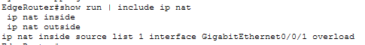
Figure 1: picture confirming inside and outside interface and overload statements on edge router

Translation table — before and after traffic
show ip nat translations on the Edge Router, captured before generating any traffic, showing the table empty or minimal.
Ping 198.51.100.10 from an internal PC, then immediately run show ip nat translations on the Edge Router. Shows the PC's private address mapped to the router's public address, with a port number.
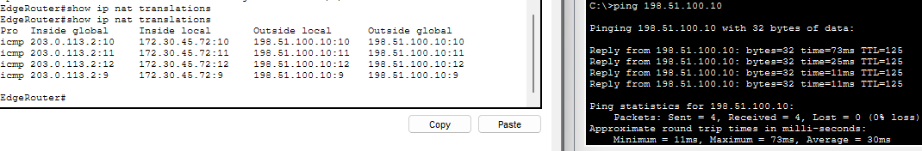
Figure 2: translation table before and after traffic, with ping to the internet from internal PC
PAT confirmed across multiple VLANs
Ping from PCs in two or three different VLANs, then run show ip nat translations once. Shows multiple private addresses sharing the same public address, differentiated by port — this is the clearest single piece of evidence that PAT is working as designed.
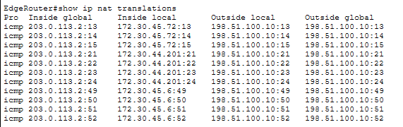
Figure 3: translation table showing internet traffic from different PC’s in different VLANs
NAT statistics
show ip nat statistics on the Edge Router, showing a non-zero hit count.
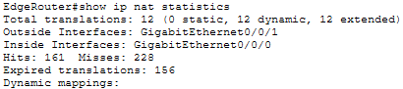
Figure 4: NAT statistics after internet traffic from different PC’s in different VLANs
Internet reachability confirmed from a representative sample of PCs
Ping results from PCs in different VLANs (including Guest) to 198.51.100.10, showing successful replies in each case.
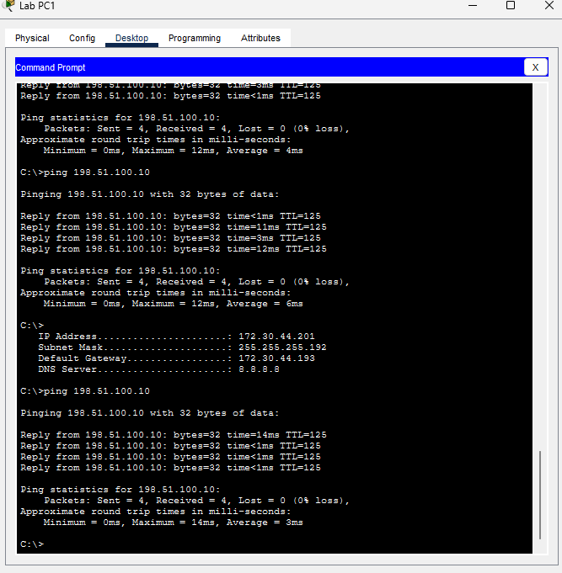Figure 5: Ping result from Lab PC(ping at the bottom)
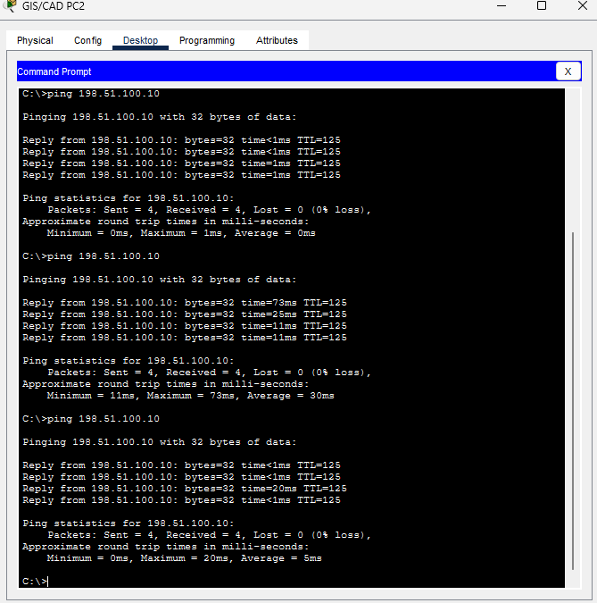
Figure 6: Ping result from the GIS/CAD PC(ping at the bottom)
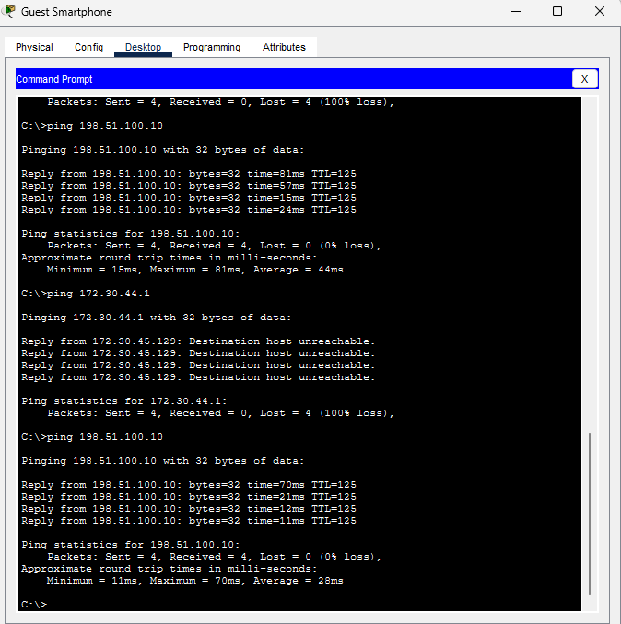
Figure 7: Ping from Guest smartphone(ping at the bottom)

Guest isolation holding alongside internet access
Ping from a Guest device to an internal address (fails) and to the internet server (succeeds), demonstrating that NAT provides internet access without compromising the isolation ACL.
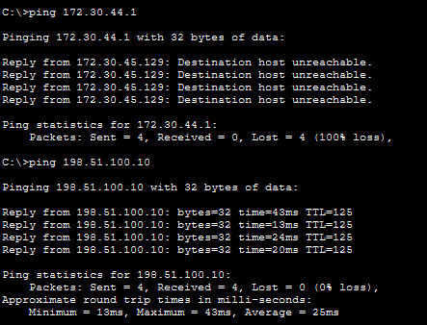
Figure 8: ping to admin PC(top of image) and ping to internet(bottom of image). This is proof of ACL use segregating guest WIFI from internal VLANs.

